### Current Activities

The museum has seen a busy month repairing damaged Oslo machines and doing some major reorganisation. The 416 tabulator is back on four wheels and the 550 interpreter now has a prosthetic leg to take the weight whilst the cast iron original is super glued in place. One of the two master clocks is now back to working order and is on display in the “C R” origins room. This now only needs minor tweaks to the pendulum length to regulate timekeeping, the clock only lost about 1.1/2 minutes over the Christmas period.

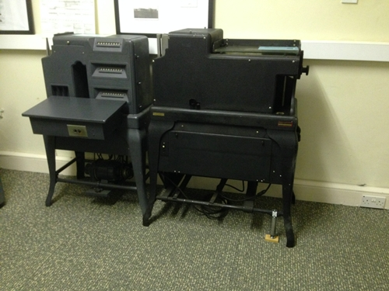 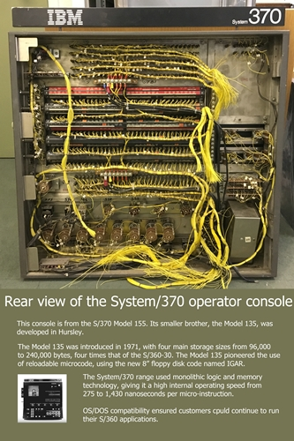

We have now decided how best to display the System/370 console, which will go out in the next week or two. The rear is nearly as interesting as the front, so we’ve done a poster size photograph to sit next to it. Hanging from the ceiling could allow 360 degree viewing, but at around 100Kg we thought that maybe wasn’t the best solution.

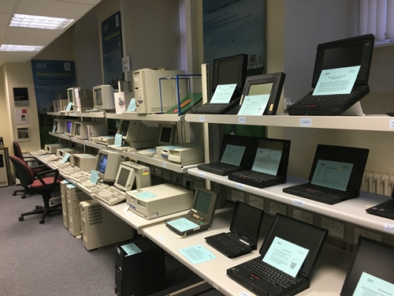

We have replaced the top shelf of many of the two storey display tables with two narrower shelves. The personal computer room has been reorganised into timeline format, starting with System/23 and the IBM PC. Some PS/2s have been removed and a selection of ThinkPads moved from their previous location in their place.

The old video control room now houses the ASCII terminals, token ring / network workstation and point of sale in place of the ThinkPads. The AS/400 display now occupies the previous RISC room, with the RISC machines displayed alongside PCs.

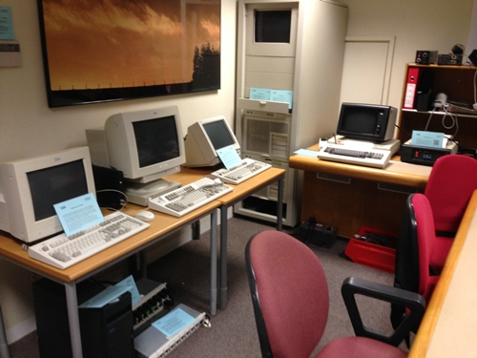 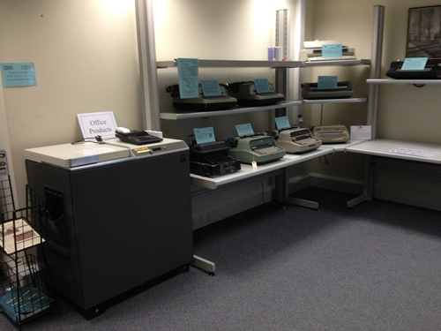

The space freed up by the AS/400s has allowed us to dedicate most of that room now to Office Products, with Copier 1, typewriters, word processors, dictating machines and DisplayWriter.